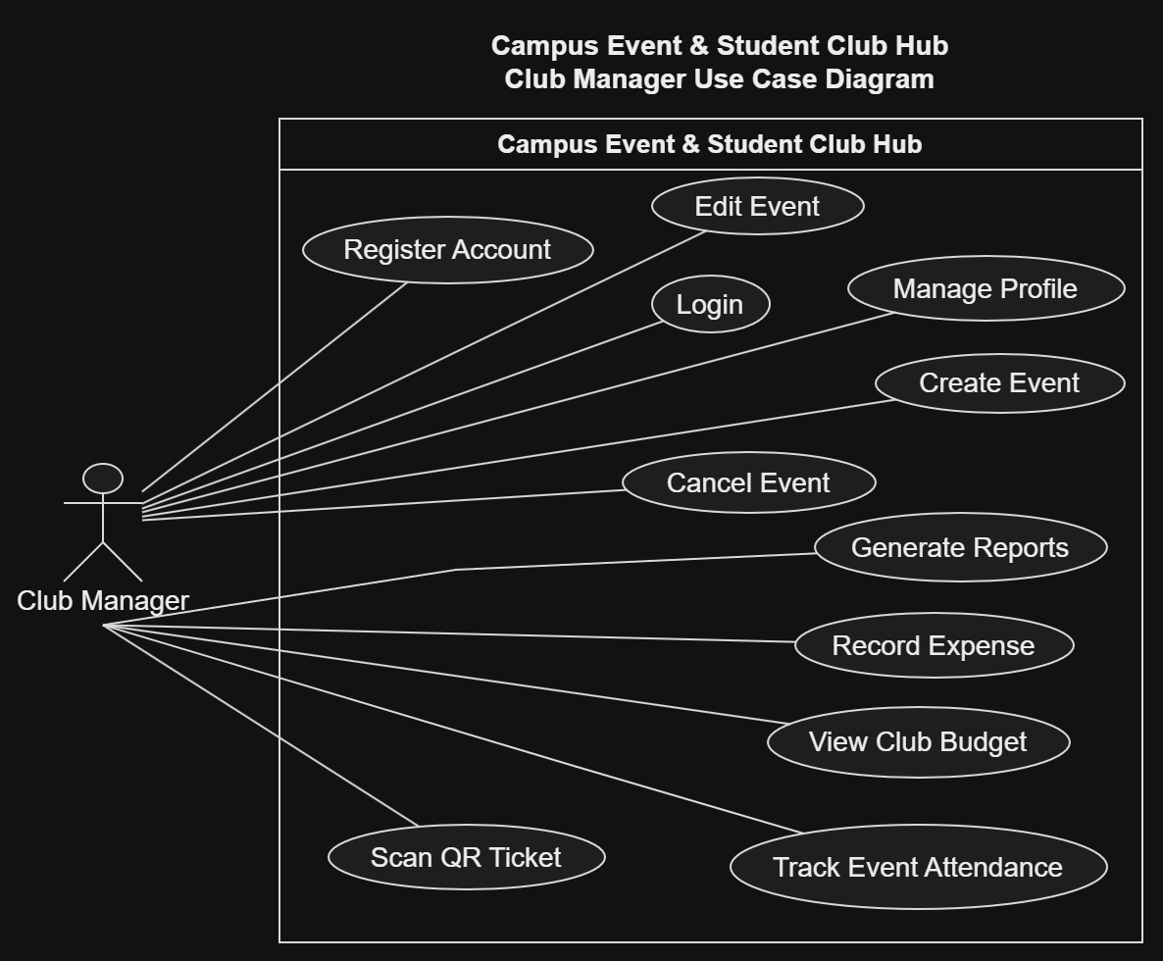
3.2.2 Use Case Descriptions
Club Manager Use Cases
1. Register Account
Use Case ID: UC-CM-01
Primary Actor: Club Manager
Related Requirement: FR-1
Preconditions:
- The user has a valid Zewail City university email.
- The user does not have an existing account.
Main Flow:
- The user opens the registration page.
- The system displays the registration form.
- The user enters their full name, university email, and password.
- The system validates the entered information and verifies the university email domain.
- The system creates the user account.
Alternative Flows:
- If the email does not belong to the university domain, the system rejects registration.
- If the email is already registered, the system displays an error message.
Postconditions:
- A new user account is successfully created.

2. Login
Use Case ID: UC-CM-02
Primary Actor: Club Manager
Related Requirement: FR-2
Preconditions:
- The Club Manager has an existing account.
Main Flow:
- The Club Manager opens the login page.
- The system displays the login form.
- The Club Manager enters their university email and password.
- The system verifies the credentials.
- The system redirects the manager to the dashboard.
Alternative Flows:
- If the credentials are incorrect, the system displays an error message.
- If the manager forgets the password, the system provides a password recovery option.
Postconditions:
- The Club Manager is successfully authenticated.

3. Manage Profile
Use Case ID: UC-CM-03
Primary Actor: Club Manager
Related Requirement: FR-3
Preconditions:
- The Club Manager is logged into the system.
Main Flow:
- The Club Manager opens the profile settings.
- The system displays the manager's current personal information.
- The manager updates profile details, such as profile picture or major.
- The manager clicks Save.
- The system validates and saves the updated information.
Alternative Flows:
- If invalid information is entered, the system displays an error message.
- If the manager cancels the operation, the existing information remains unchanged.
Postconditions:
- The manager's personal profile is successfully updated.

4. Create Event
Use Case ID: UC-CM-04
Primary Actor: Club Manager
Related Requirement: FR-5
Preconditions:
- The Club Manager is logged into the system.
- The manager has permission to create events for an assigned club.
Main Flow:
- The Club Manager selects Create Event.
- The system displays the event creation form.
- The manager enters the event title, date, time, location, capacity, and description.
- The manager submits the event.
- The system validates the entered information.
- The system saves the event with Pending Approval status.
- The event is submitted for Admin review.
Alternative Flows:
- If required information is missing, the system requests the missing details.
- If the entered information is invalid, the system displays an error message.
Postconditions:
- The event is saved with Pending Approval status.
- The event is not visible to students until approved by an Admin.

5. Edit Event
Use Case ID: UC-CM-05
Primary Actor: Club Manager
Related Requirement: FR-6
Preconditions:
- The Club Manager is logged into the system.
- The event belongs to a club managed by the Club Manager.
Main Flow:
- The Club Manager opens the list of club events.
- The manager selects an existing event.
- The manager clicks Edit Event.
- The system displays the current event details.
- The manager modifies the required information.
- The manager saves the changes.
- The system validates and updates the event details.
Alternative Flows:
- If the manager enters invalid information, the system requests corrections.
- If the manager cancels editing, the original event information remains unchanged.
Postconditions:
- The event information is successfully updated.

6. Cancel Event
Use Case ID: UC-CM-06
Primary Actor: Club Manager
Related Requirement: FR-6
Preconditions:
- The Club Manager is logged into the system.
- The event belongs to a club managed by the Club Manager.
- The event has not already been canceled.
Main Flow:
- The Club Manager selects an existing event.
- The manager clicks Cancel Event.
- The system requests confirmation.
- The manager confirms the cancellation.
- The system updates the event status to Canceled.
- The system automatically sends cancellation notifications to registered students.
Alternative Flows:
- If the manager rejects the confirmation, the event remains unchanged.
- If the event is already canceled, the system displays an appropriate message.
Postconditions:
- The event is canceled.
- Registered students are notified of the cancellation.

7. Track Event Attendance
Use Case ID: UC-CM-07
Primary Actor: Club Manager
Related Requirement: FR-12
Preconditions:
- The Club Manager is logged into the system.
- The event exists and has registered attendees.
Main Flow:
- The Club Manager selects Track Event Attendance.
- The system displays the event attendance interface.
- The manager selects the event.
- The system displays the attendance records.
- The manager can review the attendance status of registered students.
- The system displays the updated attendance information.
Alternative Flows:
- If no students have registered, the system displays an empty attendee list.
- If attendance information is unavailable, the system displays an error message.
Postconditions:
- The Club Manager can view the current attendance records.

8. Scan QR Ticket
Use Case ID: UC-CM-08
Primary Actor: Club Manager
Related Requirement: FR-12
Preconditions:
- The Club Manager is logged into the system.
- The student has a valid digital ticket.
- The event is currently accepting attendance check-ins.
Main Flow:
- The Club Manager opens the QR scanning interface.
- The manager scans the student's QR ticket.
- The system verifies the ticket information.
- The system checks the student's event registration.
- The system updates the student's attendance status to Attended.
- The system displays a successful check-in confirmation.
Alternative Flows:
- If the QR code is invalid, the system rejects the ticket.
- If the student is not registered for the event, the system denies check-in.
- If the student has already checked in, the system displays an appropriate message.
Postconditions:
- The student's attendance status is successfully recorded.

9. View Club Budget
Use Case ID: UC-CM-09
Primary Actor: Club Manager
Related Requirement: FR-13
Preconditions:
- The Club Manager is logged into the system.
- The manager has access to the club's financial information.
Main Flow:
- The Club Manager opens the club financial dashboard.
- The system retrieves the allocated club budget.
- The system displays the total budget.
- The system displays recorded expenses.
- The system displays the remaining available balance.
Alternative Flows:
- If no budget has been allocated, the system displays the available financial information.
- If the financial records cannot be retrieved, the system displays an error message.
Postconditions:
- The Club Manager can view the current financial status of the club.

10. Record Expense
Use Case ID: UC-CM-10
Primary Actor: Club Manager
Related Requirement: FR-14
Preconditions:
- The Club Manager is logged into the system.
- The manager has permission to record club expenses.
Main Flow:
- The Club Manager opens the financial dashboard.
- The manager selects Record Expense.
- The system displays the expense form.
- The manager enters the expense amount, description, and related event.
- The manager submits the expense.
- The system validates the entered information.
- The system records the expense.
- The system automatically deducts the amount from the club's available budget.
Alternative Flows:
- If the expense amount is invalid, the system displays an error message.
- If required information is missing, the system requests the missing details.
Postconditions:
- The expense is recorded successfully.
- The remaining club budget is updated.

11. Generate Reports
Use Case ID: UC-CM-11
Primary Actor: Club Manager
Related Requirement: FR-20
Preconditions:
- The Club Manager is logged into the system.
- The manager has access to the relevant club records.
Main Flow:
- The Club Manager opens the Reports section.
- The manager selects the required event or reporting period.
- The manager requests a report.
- The system retrieves attendance and expense information.
- The system generates a CSV report.
- The manager downloads the generated report.
Alternative Flows:
- If no records are available, the system displays an appropriate message.
- If report generation fails, the system displays an error message.
Postconditions:
- The requested report is successfully generated and downloaded.

